Case Study: Example of Best Practice in Promoting Mobility
Title:
University of Limerick Study Abroad Fair – An exercise in effective and inclusive engagement

Overview:
UL international education division support students and promotes diverse and inclusive Erasmus opportunities through the provision of information and guidance at their annual fair at the University of Limerick.

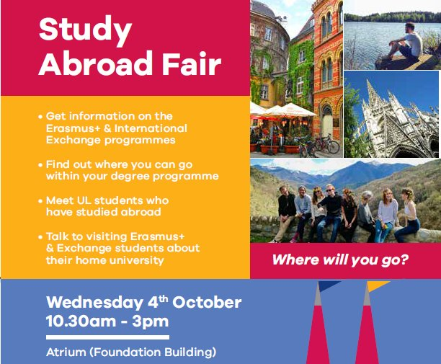
Case Study Background/Context:
The UL International Education Division (IED) engage in a 360 degree marketing approach, which includes online and offline marketing channels. Students engage with all of UL’s chosen social media channels (Facebook, Twitter). However, IED have found that face to face communication has proven to be the most successful form of engagement with students. Therefore, the Study Abroad Fair remains the most effective communication and marketing method to inform students about Erasmus opportunities.

Summary (Short bulleted paragraphs will suffice):
The Study Abroad Fair is a 1 day event aimed at informing students about Erasmus opportunities, academic credit transfer, travel tips, extra-curricular opportunities and information on host universities and cities.

UL students are given the unique opportunity to meet with returned Erasmus students who have studied abroad. This peer to peer learning opportunity allows students to feel safe asking questions about a fellow students experience and will get information that is relevant to them specifically.

At the fair, students can meet with representatives from the IED to ask questions about grants, financial information, suitability and what to expect before during and after their experience.

If a student wishes to self-identify within an access category, the IED have specific guidance and information to meet each students’ needs. This fun, open and casual environment allows for students to chat in a relaxed manner, where even the most vulnerable student categories can enquire about their Erasmus options and voice their concerns without judgement.

Each year, information is available at stands from over 50 partner universities. Due to the sheer size of the fair and the attendance levels each year, it is also UL’s most effective marketing tool. It shows students how many students are interested in going abroad and that it is open to everyone, regardless of their socio-economic background, beliefs or presence of a disability.

The fair provides a multi-sensory information session, through the use of images, video, conversation and information leaflets, so that the session is inclusive and accessible for all types of students.

Measuring Success/Outcomes of Case: (Please provide 3 measures of success for this project- if no formal evaluation has taken place, it can be anecdotal but we would encourage specific and measurable)
Attendance: Numbers of students entering the fair is recorded and analysed year on year.
Social media: In the weeks leading up to event, it is heavily publicised on UL’s social media channels i.e. Facebook, Twitter, and the IED website. Competitions are used to increase engagement and draw more students to the event. The IED use hashtags and website analytics to gauge online levels of engagement.
Self-Presentation Tracking: When students enquire about how to undertake an Erasmus period at the Study Abroad fair, the IED officers take note of each person they engage with and follow up where relevant. The fair gives a great indication of interest levels from students, and the types of perceived barriers they are facing. Student support officers offer financial assistance information and highlight courses with compulsory mobility activity so as to help students identify and acknowledge their concerns. The student data acquired by the IED and student officers remains strictly confidential and for internal analysis only, unless otherwise requested by the student.
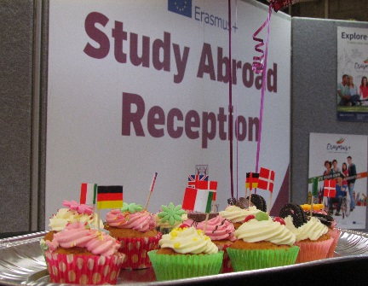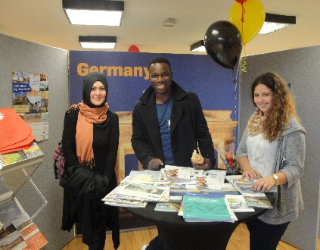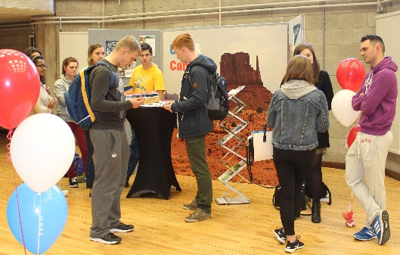
Three tips from your institution for other HEIs:
- The Study Abroad Fair is the most effective tool for information provision, communication and fact finding which informs the marketing strategy for the year ahead. Students respond very well to the come and go option, and can stay for as long as they need to.
- It is important to stay in regular contact and work together with other offices which support students in the university. I.e. Access Officer, finance dept., student union, health & welfare dept. etc. IED is always equipped with up to date information and stays well informed on opportunities and requirements for students interested in engaging with Erasmus opportunities.
- Incentivise and encourage students to take part in Erasmus, through clever marketing, joined up thinking and a strong host university offering. A clear and effective international strategy will ensure students continue to be inspired and understand the many benefits of Erasmus, from personal development to future employability.

